NASA Looking for Life in Trappist 1 Star System is not a Smart Idea By Ruwan Rajapakse, PE

Ruwan Rajapakse, PE
Lately, a lot has been written on the Trappist 1 planetary system. The interest is due to the fact that there could be life on one of the planets in the system.
But let us take a look at the data.
Before we discuss the Trappist 1 planetary system, let us look at our solar system.
As we all know, when a planet is further away from the parent star it will not be able to maintain liquid water. Any water would be in the form of ice. On the other hand, when the planet is closer to the parent star any water would evaporate. The limited narrow zone where a world can maintain liquid water is known as the Goldilocks zone. In our solar system, this zone spans from 0.5 astronomical units (AU) from the sun to 1.5 astronomical units from the sun (Ref 1). One astronomical unit (1 AU) is equal to the distance between the sun and the earth.
Press enter or click to view image in full size
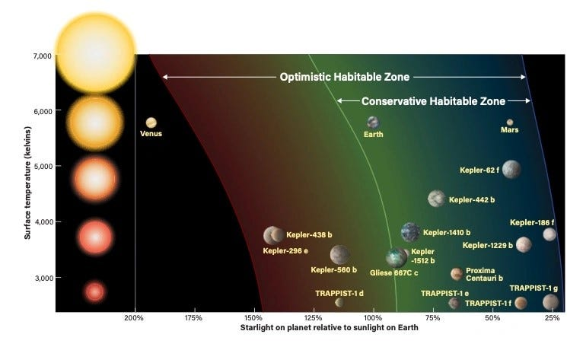
Fig 1. Habitable Zones of Different Exoplanets.
Any planet closer than 0.5 AU, would be too hot for liquid water to exist. On the other hand, anything further away than 1.5 AU is too cold and the water would freeze. Hence our habitable zone is approximately a band of 1.0 AU.
Get Ruwan Rajapakse, PE’s stories in your inbox
Join Medium for free to get updates from this writer.
Subscribe
Now let us take a look at the parent star of the Trappist 1 system. This star is much smaller than our sun. Trappist 1 star is only 10 percent of the mass of our sun. As per NASA (Ref 2) its energy output is only 0.0005 of our sun.
Press enter or click to view image in full size
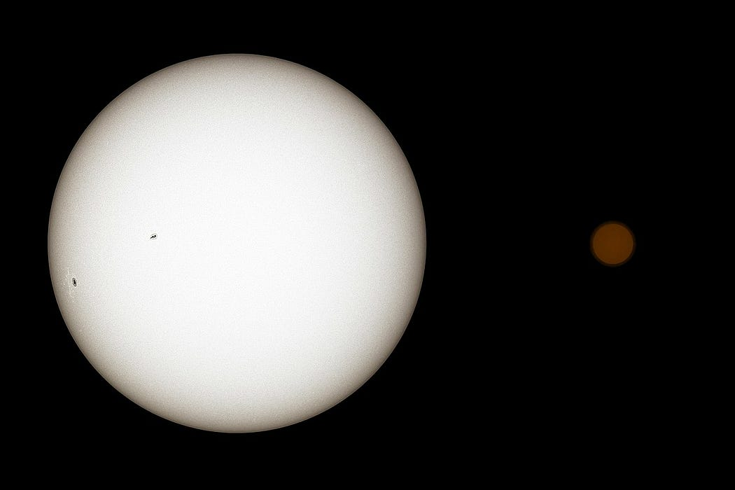
Our Sun is on the Left and Trappist 1 is on the Right
The energy is dissipated to an area of 4.π R2 from the center. The energy dissipation reduces at a rate of R2 from the star. As per NASA, Trappist 1 energy output is 0.0005 of our sun.
Hence the Goldilocks zone or the habitable zone of Trappist 1 system should be 0.5*√0.0005 AU to 1.5*√0.0005 AU.
Press enter or click to view image in full size
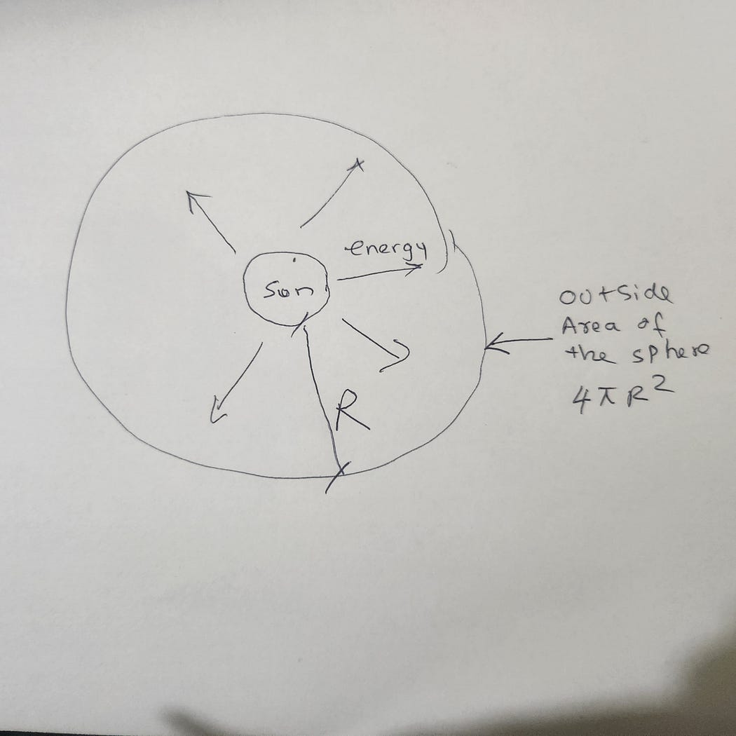
The energy of our sun dissipates to a sphere with radius R which has a surface area of 4.pi R2
This simplifies to a habitable zone of 0.011 AU to 0.033 AU from the star. The distance of the habitable is only 0.022 AU!
1 AU is 93 million miles. Hence 0.022 AU would be only 2 million miles. This is only ten times the distance to the moon. For life to persist, a planet has to form in that very narrow band. Not only that, the planet has to stay in that narrow band for billions of years for life to evolve from basic elements to complex life. Not to mention there are a bunch of other planets in the vicinity of the system.
Overall the chances of a planet forming and staying in this narrow band are almost zero. Also, remember that just because there is a planet in the habitable zone, does not mean complex life would form.
REFERENCES:
1. ASTRONOMY: ROEN KELLY, AFTER Chester Harman/PHL at UPR Arecibo/NASA/JPL
2. https://solarsystem.nasa.gov/news/335/10-things-all-about-trappist-1

